**Dokumen Desain**

**“Form Online”**

Oleh:

171022000045 – Jati Prasetyo (Github : jattiblee)

171022000062 – Juri Pebrianto (Github : aquarink)

171022000044 – Riky Susanto (Github : riky-cloud)

1. **Class Diagram**

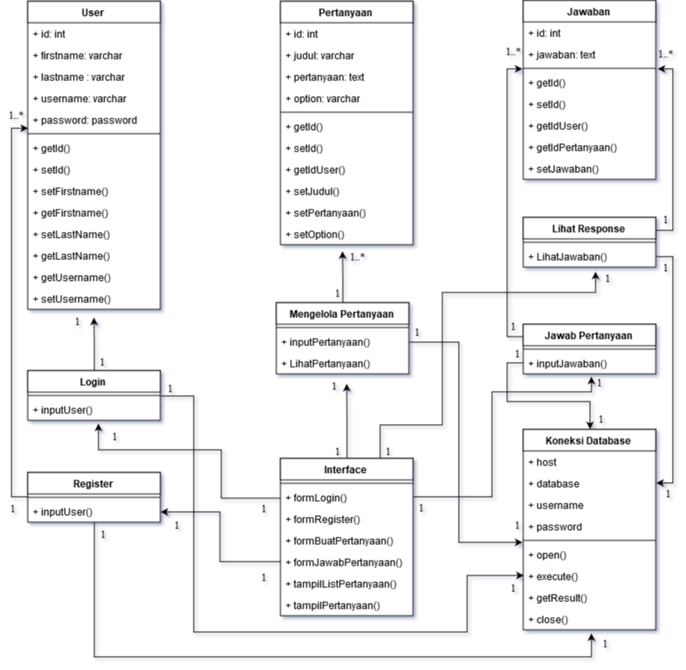

1. Sequence Diagram

